Student ID: 700747817

Name: Manikanta Venkata Kondasai Kalyan Badeti Parameswara

Machine Learning - Assignment III

Video Link: https://drive.google.com/file/d/17RqxJgkDSfj_fGJmYbaXJ1VGkuupukLe/view?usp=share_link

GitHub Link: https://github.com/Kalyansai6/ML---Assignment-3

1. NumPy:

1. Using NumPy create random vector of size 15 having only Integers in the range 1-20.

import numpy as np

x = np.random.randint(1,20, size = 15)

print (x)

Description: Here we’ve imported numpy and used radint function to print random integers with the max value below 20 and number of integers as 15.

1. Reshape the array to 3 by 5

y=x.reshape(3,5)

print(y)

Description: We have reshaped the array to 3 by 5 using reshape function.

1. Print array shape.

print("array is :",y)

print ("array shape is:",y.shape)

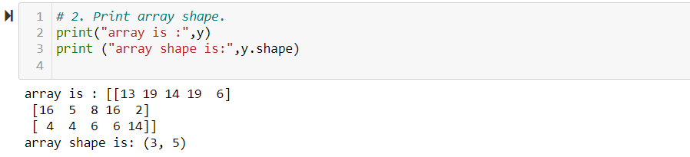

Description: We have printed the shape of the array which is 3 by 5 using Shape function.

1. Replace the max in each row by 0

new_a = np.where(y == [

[i]

for i in np.amax(y, axis = 1)

], 0, y)

print(new_a)

Description: Here, first we have pulled the maximum value of the array using amax function and replaced the maximum value using for loop.

Create a 2-dimensional array of size 4 x 3 (composed of 4-byte integer elements), also print the shape, type and data type of the array.

# create a 2-dimensional array of size 4x3

arr = np.array([[1, 2, 3], [4, 5, 6], [7, 8, 9], [10, 11, 12]], dtype=np.int32)

# print the array shape

print("Array shape:", arr.shape)

# print the array type

print("Array type:", type(arr))

# print the array data type

print("Array data type:", arr.dtype)

Description: Here, first we have created a 2-dimensional array and printed the shape, type and data type using arr.shape, type and arr.dtype functions respectively.

1. Write a program to compute the eigenvalues and right eigenvectors

import numpy as np

# define the square array

A = np.array([[3, -2], [1, 0]])

# compute the eigenvalues and right eigenvectors

eigenvalues, eigenvectors = np.linalg.eig(A)

# print the eigenvalues and right eigenvectors

print("Eigenvalues:", eigenvalues)

print("Right eigenvectors:")

print(eigenvectors)

Description: Here, we have defined an array and then computed the eigenvalues, eigenvectors using the linalg.eig function. Post that we have printed those values using the print function.

1. Compute the sum of the diagonal element of a given array.

import numpy as np

# define the array

A = np.array([[0, 1, 2], [3, 4, 5]])

# compute the sum of the diagonal elements

diagonal_sum = np.trace(A)

# print the sum of the diagonal elements

print("Sum of diagonal elements:", diagonal_sum)

Description: We have defined an array first and used np.trace function to compute the sum of diagonal elements which is 0 & 4. So, in the execution, we got diagonal sum as 4.

1. Write a NumPy program to create a new shape to an array without changing its data.

import numpy as np

# define the original array

arr = np.array([[1, 2], [3, 4], [5, 6]])

# reshape to 3x2

arr_3x2 = arr.reshape(3, 2)

# reshape to 2x3

arr_2x3 = arr.reshape(2, 3)

print("Reshaped to 3x2:\n", arr_3x2)

print("Reshaped to 2x3:\n", arr_2x3)

Description: We have defined an array first and then reshaped them to 3x2 and 2x3 respectively using the arr.reshape function.

2. Matplotlib

Write a Python programming to create a below chart of the popularity of programming Languages.

import matplotlib.pyplot as plt

# Data to plot

languages = 'Java', 'Python', 'PHP', 'JavaScript', 'C#', 'C++'

popuratity = [22.2, 17.6, 8.8, 8, 7.7, 6.7]

colors = ["#1f77b4", "#ff7f0e", "#2ca02c", "#d62728", "#9467bd", "#8c564b"]

# explode 1st slice

explode = (0.1, 0, 0, 0,0,0)

# Plot

plt.pie(popuratity, explode=explode, labels=languages, colors=colors,

autopct='%1.1f%%', shadow=True, startangle=140)

plt.axis('equal')

plt.show()

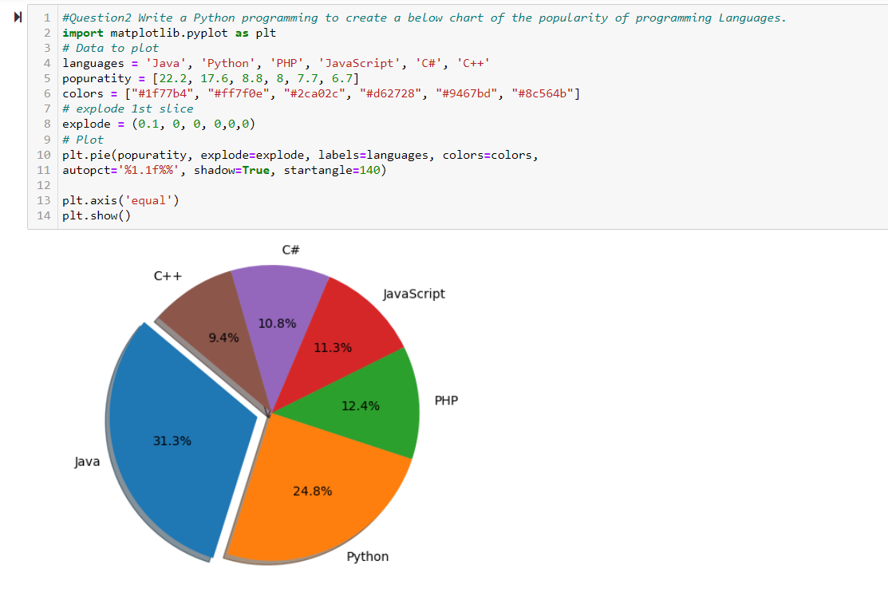

Description: We imported the matplotlib initially and then we have defined the data which are languages, popularity, colors. And then using plt.pie function, we have got to execute the pie diagram which sums up to 100% covering all the data we defined.